8086 LAB PROGRAMS

NAME: SHIVATHMIKA V

REGNO:192521028
- Write an assembly language program for adding two 16-bit data using 8086 processor.
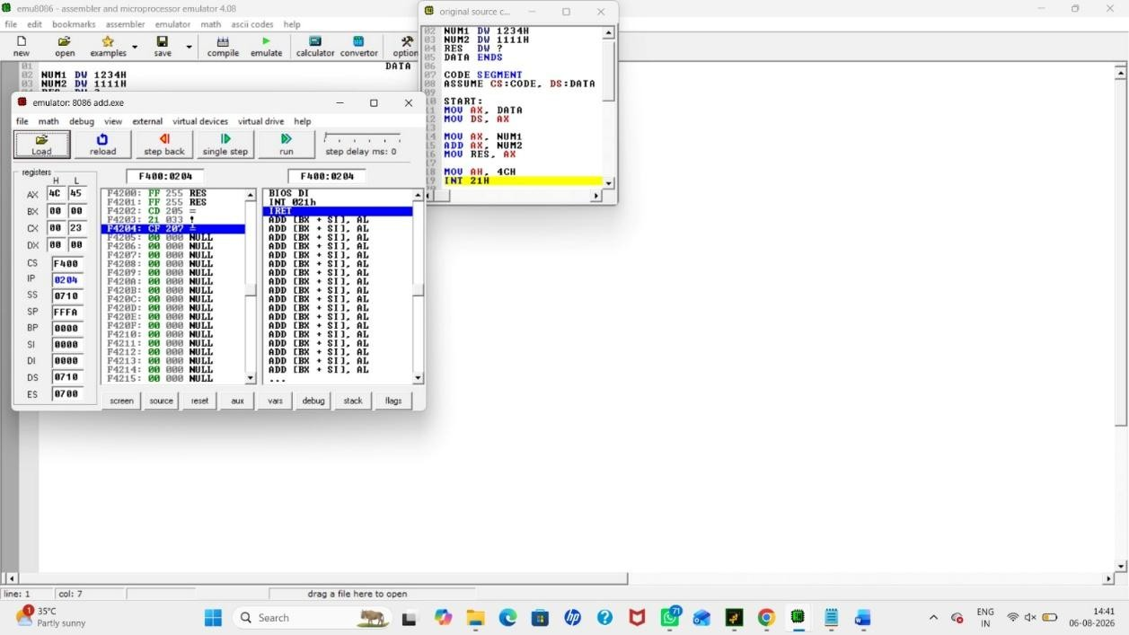
- Write an assembly language program for subtracting two 16-bit data using 8086 processor.

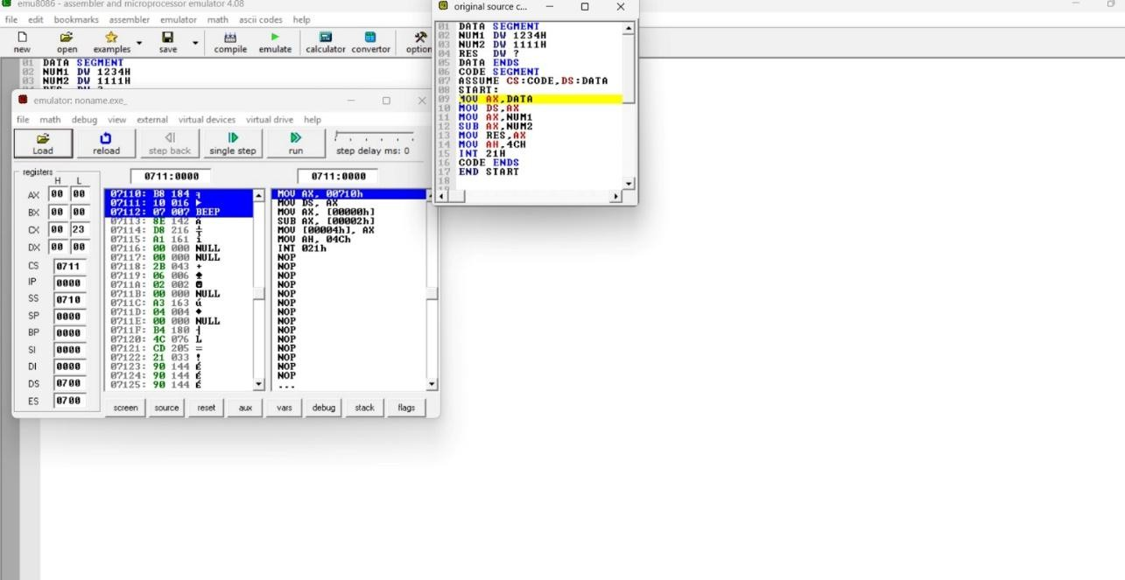

- Write an assembly language program for multiplying two 16-bit data using 8086 processor.

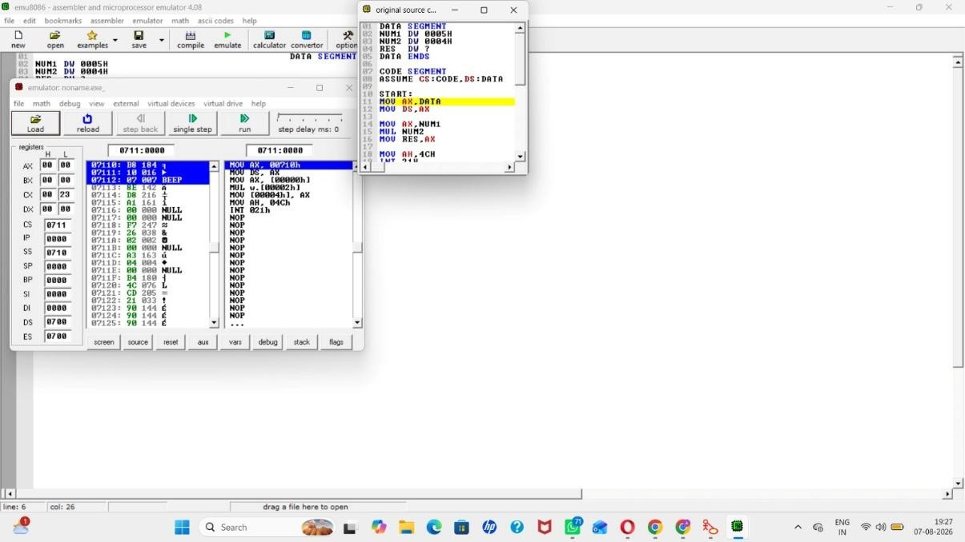
- Write an assembly language program for dividing two 16-bit data using 8086 processor.

